1. Healthcare Access & Community Sanitation (HACS) Program
At HopeRise, we believe that access to quality healthcare is a basic human right for every child and adult. Yet in the Kirangira community we serve, many vulnerable families face barriers such as limited medical facilities, high healthcare costs, and low awareness of preventive care. As a result, many remain exposed to preventable illnesses, malnutrition, and serious health complications.
Through our community clinic, Valentine Medical Centre, we provide healthcare and medical support to the most vulnerable. We particularly work with families with adults and children living with HIV/AIDS, supporting them through counselling for adherence and reuniting those who have dropped off treatment back into care through our partner hospitals.
Our services include testing for malaria, typhoid, TB, and brucella, as well as monitoring vital signs such as blood pressure, organ function, and maternal care. We treat mild and moderate conditions and perform minor surgeries, including cases related to domestic violence.
We also conduct regular medical outreach programs, bringing essential healthcare services closer to those who need them most. These include medical check-ups, treatment for common illnesses, child immunisation, family planning services, and general clinical care.
We place strong emphasis on health education. Families are equipped with knowledge on nutrition, hygiene, maternal health, and disease prevention to improve their overall well-being.
For many children living with HIV/AIDS, access to healthcare determines whether they stay in school and thrive. For parents, it provides the strength to work and support their families.
We also recognize that sanitation is an integral part of preventive healthcare. Through partnerships with Village Health Teams (VHTs), we provide WASH training to promote hygiene and reduce infectious diseases at household level.
With continued support, we aim to expand and equip our community clinic to reach more underserved populations and provide more comprehensive care.
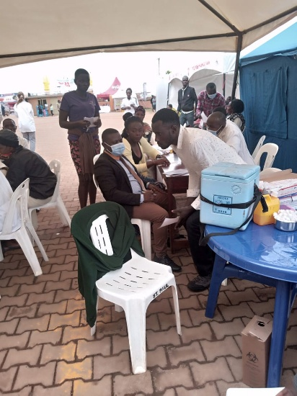
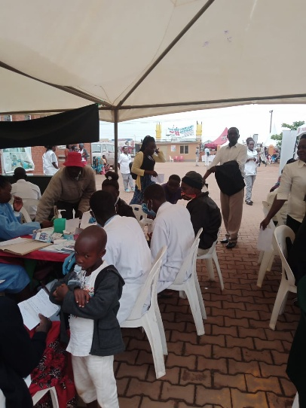
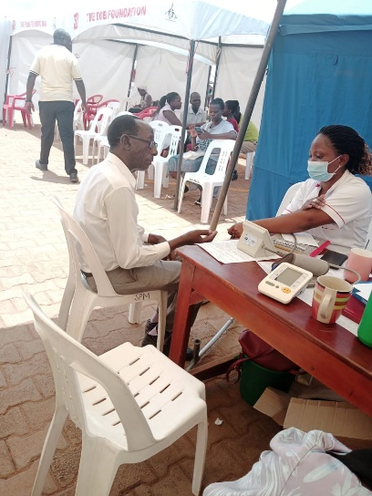
Photos for Medical

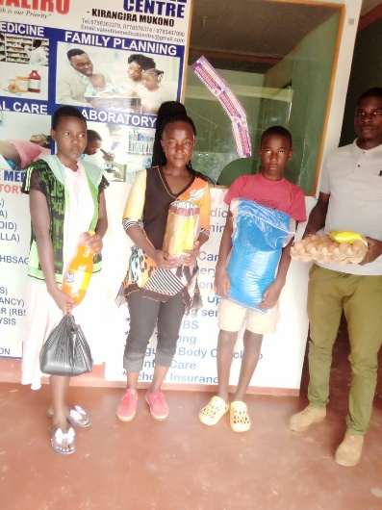
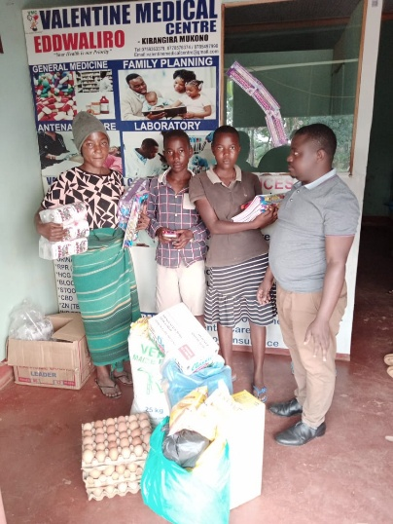
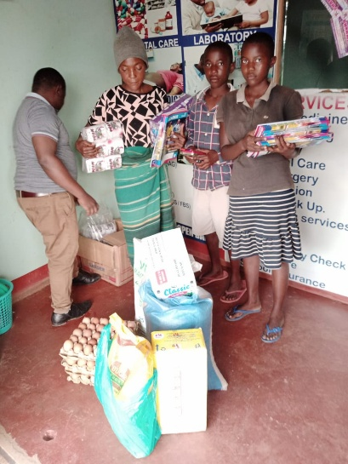
Nutritional support under medical
2. EduSave Program (Education Sponsorship and Mentorship)
At HopeRise, we recognize that education is one of the strongest foundations for transforming the future of vulnerable children and families.
Through our EduSave Program, we identify children living with HIV who are not enrolled in school, those who have dropped out, and those at risk of dropping out. We work with nearby government schools to support their return to school by providing fees and essential scholastic materials such as books, pens, shoes, and bags.
We also provide psychosocial support to help children overcome stigma and build confidence to pursue their life goals.
In addition, we advocate for girl child education and inclusion in leadership as a pathway to inclusive development.
Through partnership with EduSenga of Makerere University, we conduct school-based mentorship programs covering personal hygiene, life goal setting, academic preparation, and mental health awareness.
Recognizing the importance of reproductive health, we conduct menstrual hygiene awareness programs and train girls to make and use reusable sanitary pads. We also conduct awareness sessions on cross-generational relationships and their risks.
Students are organized into “EduSave Champions” groups under the motto “Each One, Support One.” We also integrate entrepreneurship, particularly in agribusiness, and environmental awareness into our mentorship.
Through this program, we nurture responsible, informed, and confident young people under the theme “Empower them to lead tomorrow.”
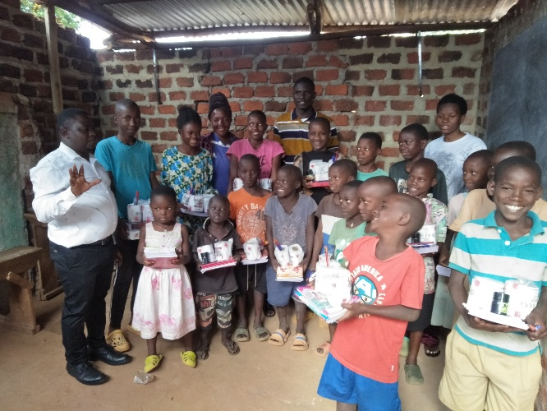
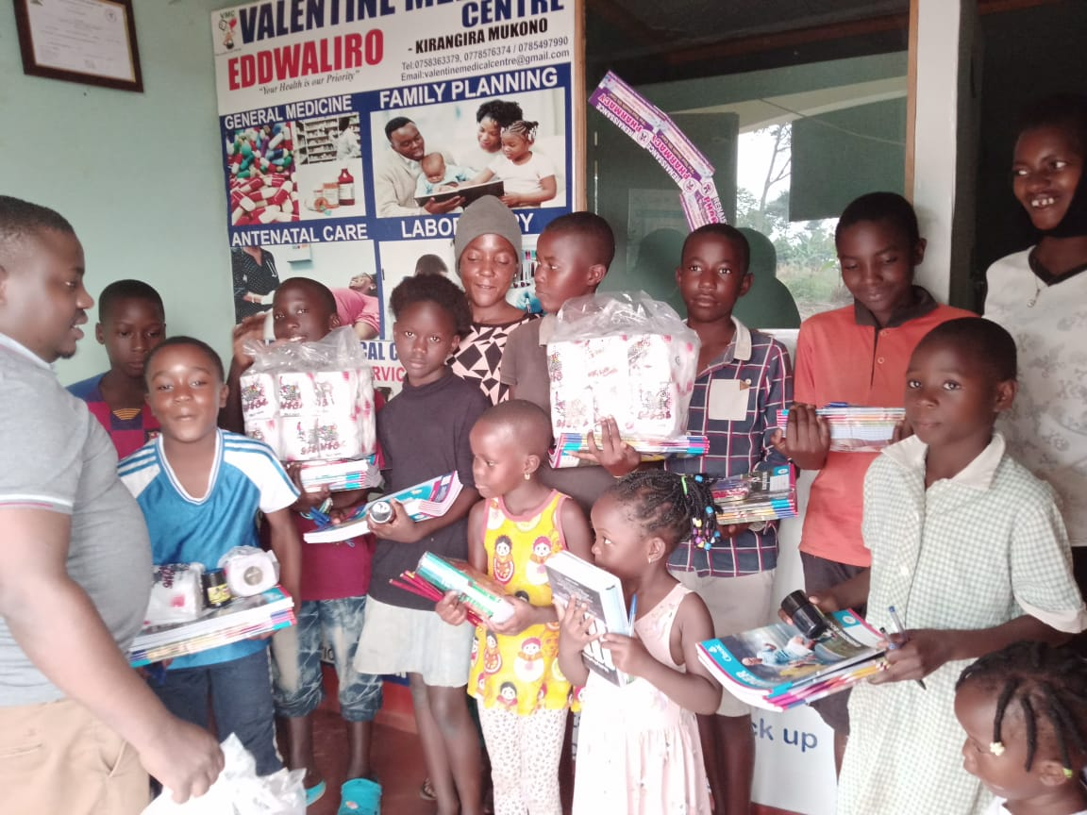
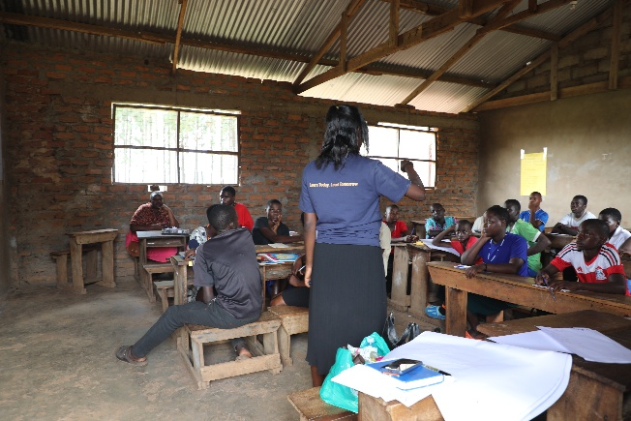
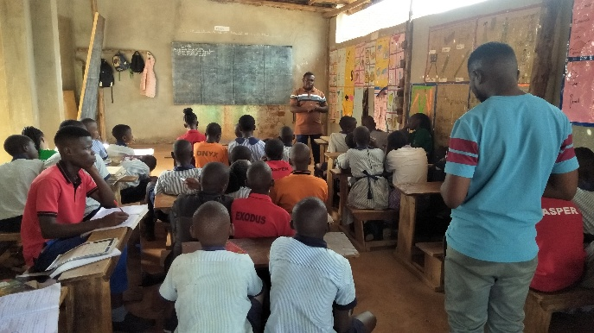
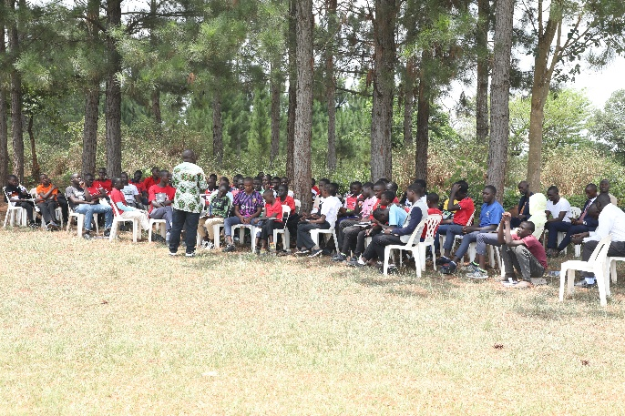
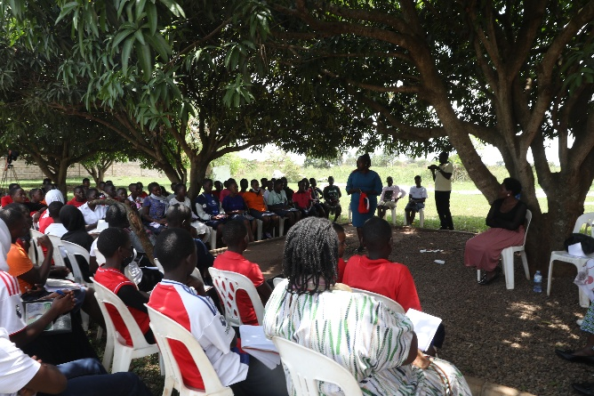
Mentorship

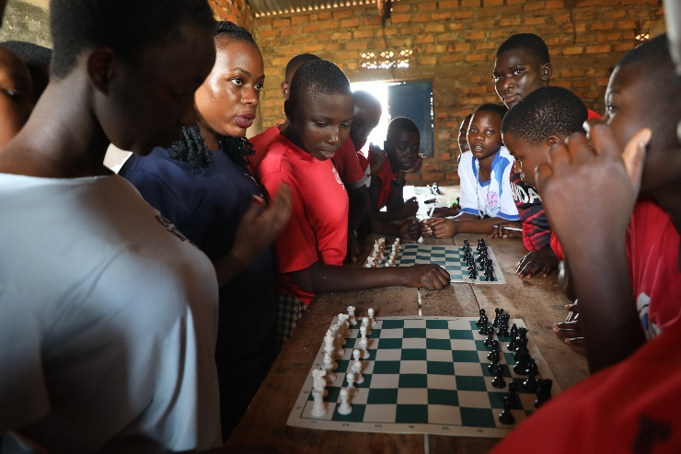
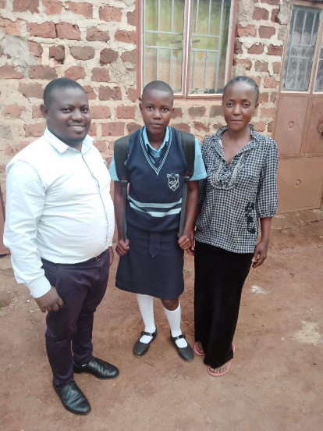
3. Self-Help Entrepreneurial Skilling & Livelihoods Development (SESLD) Program
At HopeRise, breaking the cycle of poverty requires more than short-term support. It requires equipping individuals with practical skills to build sustainable and independent livelihoods.
Many young people, women, and families in our community face unemployment, limited economic opportunities, and a lack of marketable skills. Without intervention, many turn to unsustainable livelihoods such as quarrying, deforestation, risky casual labour, and survival-based activities along Wantoni streets.
Through our Skills Empowerment Program, we provide hands-on training in carpentry, tailoring, hairdressing, and craft shoe making. These skills create immediate income-generating opportunities, especially for school dropouts and teenage mothers.
Beyond vocational training, we promote entrepreneurship, financial literacy, and community-based income initiatives. This ensures that participants are equipped not just to work, but to grow, innovate, and sustain their livelihoods.
This program restores dignity, builds self-reliance, and renews hope. With continued support, we aim to expand access to modern training tools and reach more vulnerable individuals.

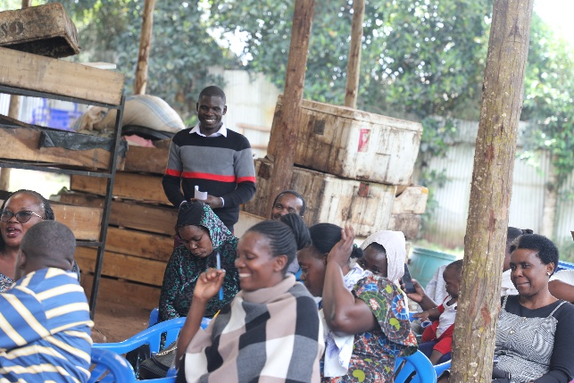
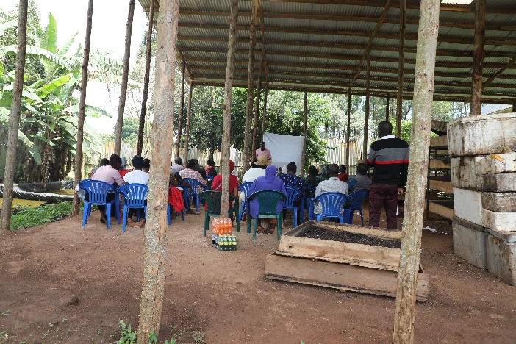
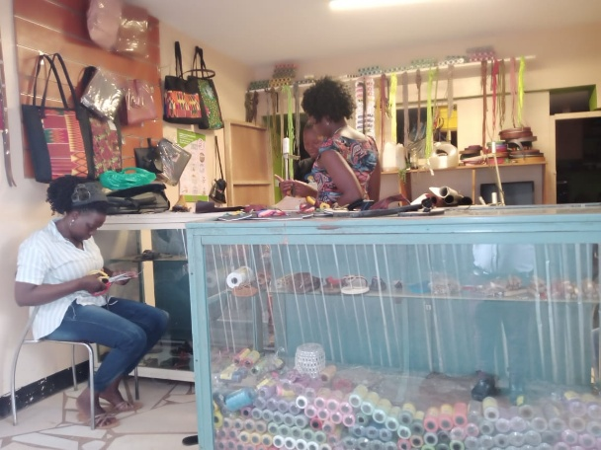
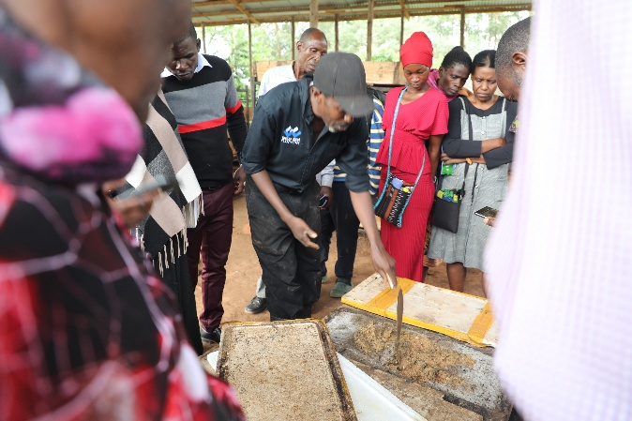
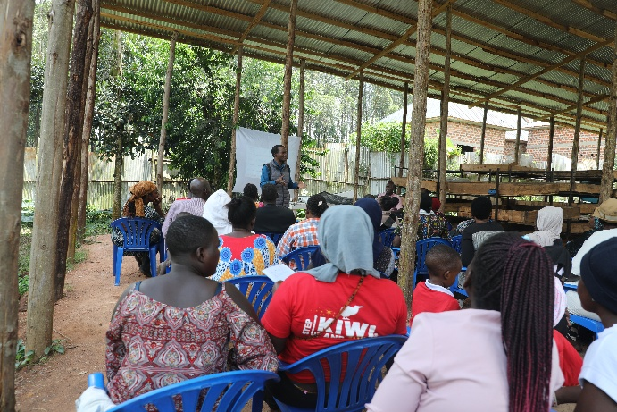
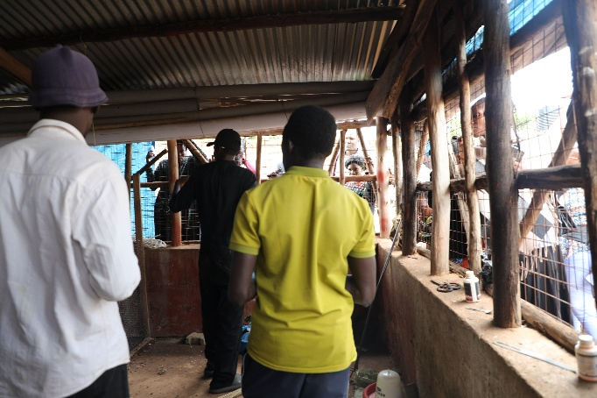
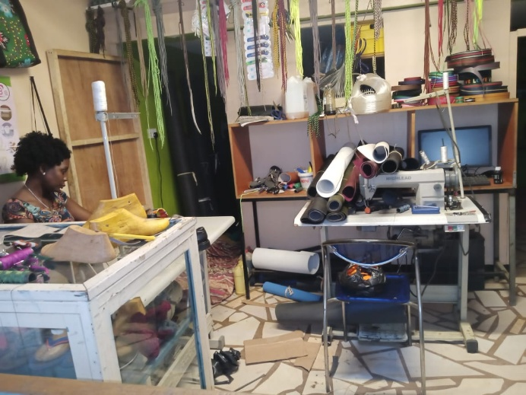
4. EcoAdapt Program for Climate Adaptation & Environmental Sustainability
At HopeRise, we understand that a healthy environment supports healthy lives. We work to build community resilience in the face of climate change through practical and locally driven solutions.
Through our EcoAdapt Program, we restore greenery around homes using agroforestry. Community members are trained to establish integrated home gardens that combine fruit trees, medicinal plants, ornamental herbs, and vegetables. These gardens improve nutrition, generate income, and support environmental restoration.
So far, we have established over 5 household gardens and 3 in primary schools, with growing community adoption.
We also address waste management. For biodegradable waste, we train communities to produce biogas for clean cooking and biofertilizer for farming. For plastic waste, we integrate recycling into craft shoe making and other products, reducing pollution while creating income opportunities.
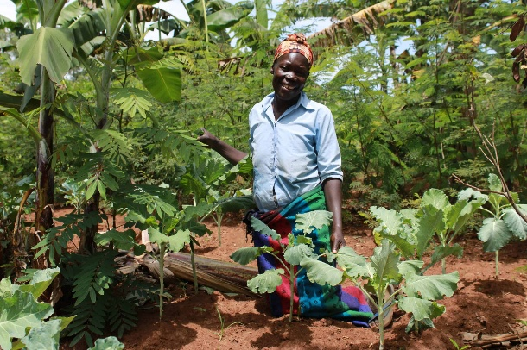
In addition, we promote climate-smart agriculture through organic farming practices. Communities are trained to grow crops such as bananas, maize, beans, cassava, vegetables, and fruits using organic manure and locally made pesticides.
